Requirement Analysis

# Introduction:

Airline reservation systems include *passenger reservations, airline schedules, and ticket records*. An airline’s direct distribution works within their reservation system, as well as pushing out information to the GDS. The second type of direct distribution channel are consumers who use the internet or **mobile applications** to make their reservations.

Check-in is an important and the first procedure for an airport passenger, as passengers are required by airline regulations to check-in at certain moments before a flight departs. The*airline check-ins are one of the main functions* for the airline, it is also important to check and screen the luggage that goes into the aircraft for the passenger as well as the security of the airport

# ****Features of Flight Reservation System:****

Highly customizable system  
Reservation cancellation system  
Trustworthy and reliable  
Multiple language support  
Multiple currency acceptances  
Secure online payment gateway  
Seamless, fast, and error-free online reservation facility to the users.

# ****Benefits of Flight Reservation System:****

* Fully customized
* User-friendly interface
* Real-time update
* Easy cancellation process
* Easy refunds after the cancellation
* 24/7 booking available for customers.

# Block Diagram:

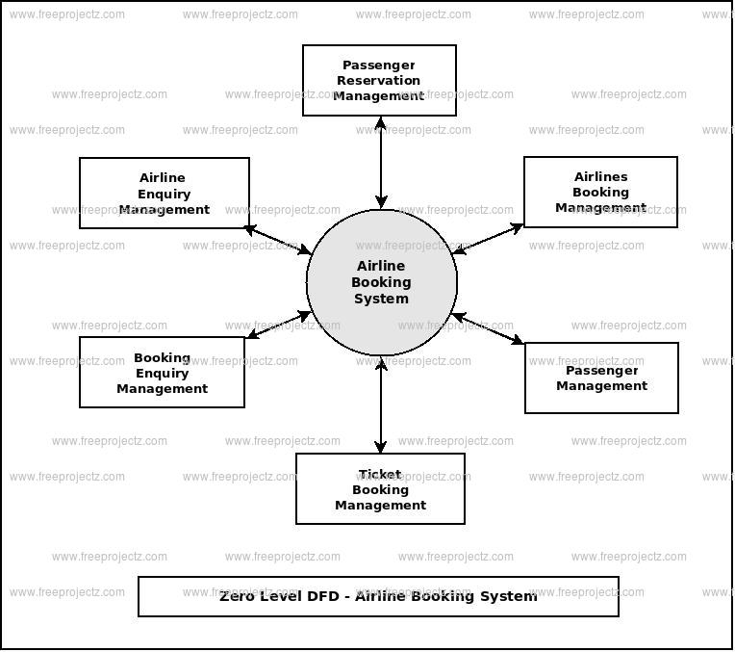

# Functional Requirements:

This section is the bulk of the document and precisely states the functions of the system – what it should do and what it should not. This section is split into subsections modeled after the real world activities like reserving tickets, rescheduling tickets etc. Freedom from ambiguity and navigability were kept in mind while documentation. A consistent terminology has been followed throughout and the terms are explained in the appendix. The subsections follow a logical sequence that reflects the real world. For example, a customer cannot reschedule a ticket unless he has bought one earlier and cannot buy one unless he has checked its availability.

# Non-functional Requirements:

These are quality requirements that stipulate the performance levels required of the system for various kinds of activities. Numerical lower and upper limits set conditions on the response times, access times etc of the system. Sometimes, tradeoffs are necessary among various non-functional requirements.

# Future Requirements:

These are the specifications which are not provided for now in the current version of ARS but which could be incorporated into future versions. Some of these need advanced technologies and interfaces with other systems. The ARS could be designed in future to enhance the existing capabilities or add entirely new ones.